# *Web Programming III (420-C30-HR)*

# *Lab 2 – Web Servers*

Date assigned: Wednesday, Sept. 2, 2015

Date due: **Wednesday, Sept 2, 2015, 6:00 p.m.**

**Learning Objectives**

Upon successful completion of this lab exercise, the student will have:

* Understand Web servers
* Understand HTTP Protocol
* Understand URLs

To do:

1. For Part B and C you **MUST** complete this lab while sitting at a computer in Room B-221 or B-219. You cannot complete it from a laptop or from a computer in another room.
2. Save this file in your labs folder as yourfirstinitialyourlastname_C30L02_WebServers.docx (e.g. jsmith_C30L02_WebServers.docx)
3. You will be using the Windows 7 snipping tool extensively in this lab. If you are not familiar with it, play with it first to get the hang of it. When you are capturing the images for the lab, capture the minimum required to prove that you completed the step. Do not capture the entire screen or massive areas of the screen. I am looking for proof that you did what was required and not that you can do a print screen. Keep the files as small as possible. To access the Windows snipping tool, select Windows » All Programs » Accessories » Snipping Tool.

To do:

Today you are going to explore a couple of popular web servers. You are going to look at Internet Information Services (IIS) which is Microsoft’s web server and you will be starting and setting up the node.js web server to return from requests.

**Part A – Moodle Quiz**

1. Complete the Lab 2 Quiz in Moodle.

**Part B – Web servers – IIS**

IIS is the Web server which was developed by Microsoft. It is used extensively in the industry, and is required at any business using .NET. The .NET framework and “pools” are closely integrated with IIS. Today we will look at the IIS portion and not the ASP.NET portion.

**Starting/Stopping IIS**

1. Start Internet Explorer, Firefox or Chrome. Enter the word localhost in the address bar. Make sure you just enter localhost and NOTHING ELSE. What is the name of the page (title) that is displayed? What is the URL of the page displayed? Use the snipping tool to capture the screen from any browser showing what was displayed and paste the result here.

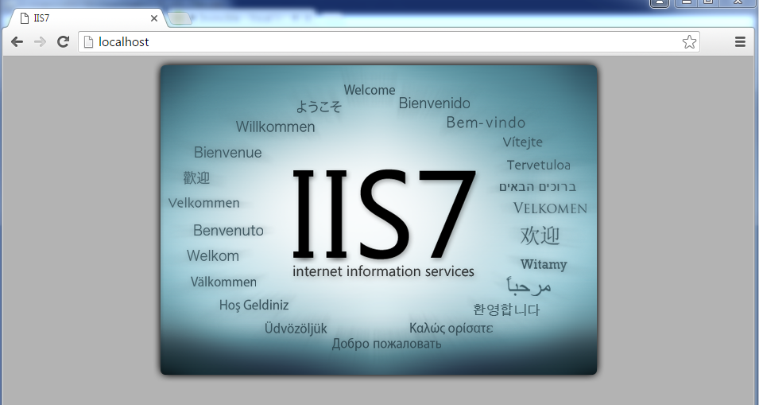

1. Start Internet Information Services (IIS) Manager from the start menu (Press start and type IIS) and expand the arrows on the **machine name** and the **sites** until the **Default Web Site** is displayed.
2. Right click on the **Default Web Site** icon and choose **Manage Web Site** and **Stop** the web server**.** Restart Internet Explorer and enter localhost as the URL. What is displayed? (Note, the display should be different; however, you may have to empty your cache to see this. To empty your cache, select the **gear icon** on the right of the screen, **Internet Options**, **Delete…** to delete your cache). Use the snipping tool to capture the screen showing what was displayed and paste the result here.

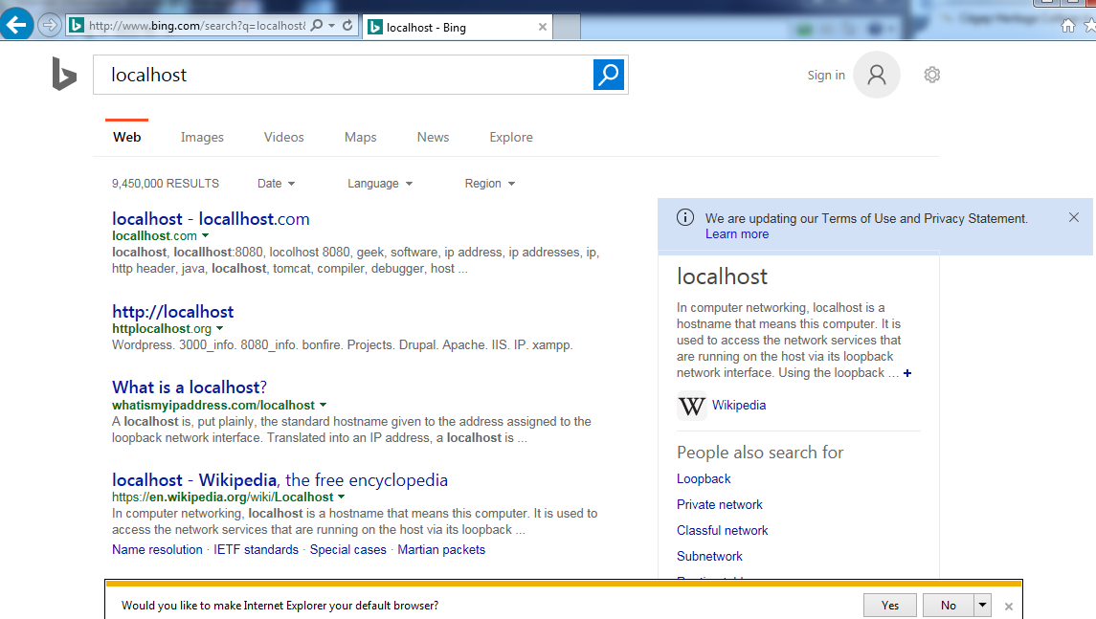

1. Start Firefox and enter localhost as the URL. What does Firefox display? (Once again, the display should be different than the first time. You may have to empty your cache by selecting the drop down from the Firefox menu (top left), Options, Privacy, Clear Recent History (unless do not Never Remember History is already selected)).Use the snipping tool to capture the screen showing what was displayed and paste the result here.  
   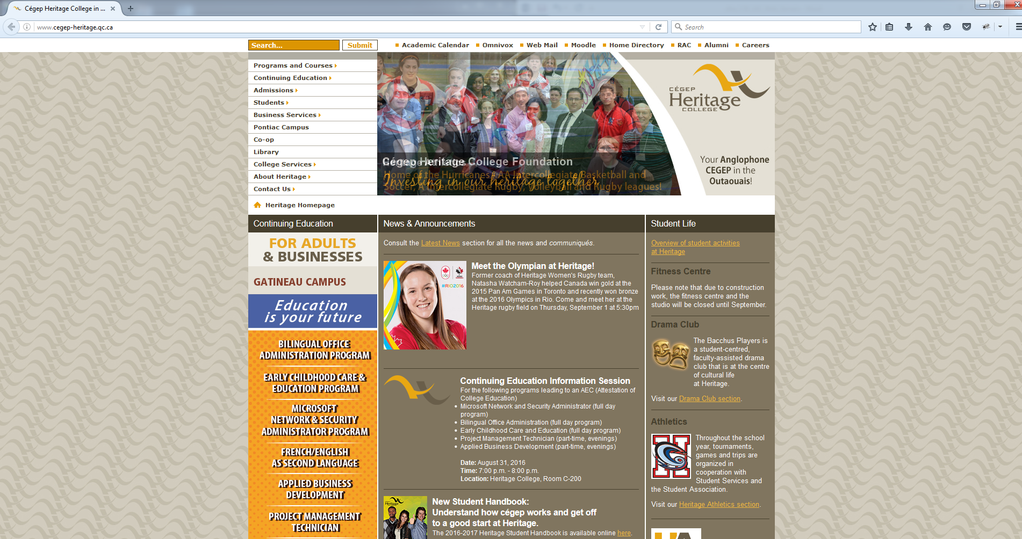
2. Do the same in Chrome. What does Chrome display? Use the snipping tool to capture the screen showing what was displayed and paste the result here.  
   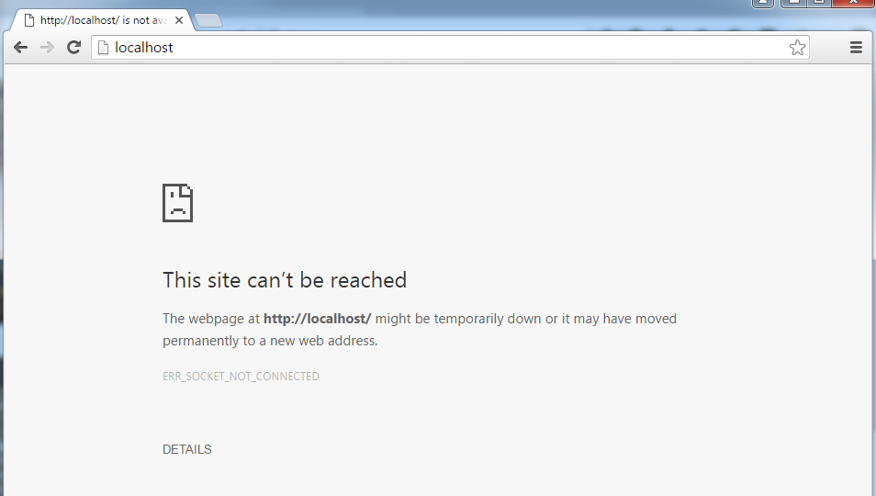
3. Do the same in Opera. What does Opera display? Use the snipping tool to capture the screen showing what was displayed and paste the result here.  
   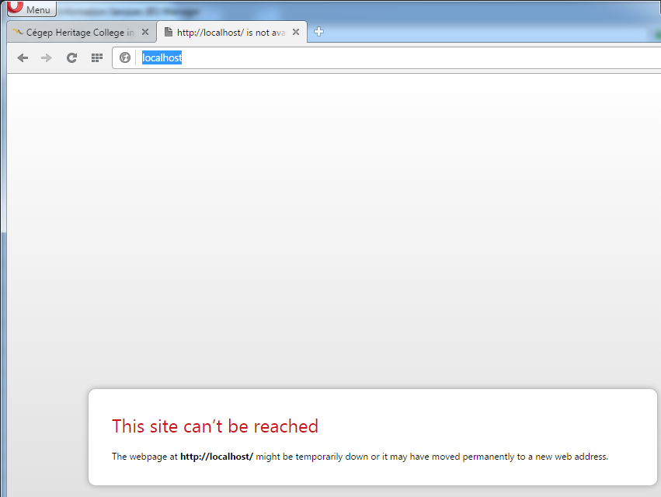
4. In your opinion, which browser handles it best and why?  
   **In my opinion Chrome handles it better because it will actually tell you that there is no localhost. Speaking from a web/programmer or a technician it is useful to know whether or not your localhost is down. The only reason why it’s better then Opera is because it also provides an error message for us.**
5. Restart IIS by right clicking on the **Default Web Site** icon and choose **Manage Web Site** and **Start**. Double check that IIS has restarted by checking localhost in a browser.

**IIS Manager Groupings**

1. Make sure that the Default Web Site is selected. How are the various items grouped? What are the three different major parts of this grouping?   
   **They are grouped by ASP .NET, IIS, Management. The three different parts is that one is more for developers (.NET), the other is for services, and the last one is for management.**

**Default Documents**

1. Double click on the **Default Document** icon. What is the default document for your webserver?   
   **Default.htm**
2. Select the **iisstart.htm** option and select **Remove** from the **Actions** on the right. Use the snipping tool to capture the screen showing what was displayed in the IIS manager and paste the result here. Restart a browser and enter localhost for the URL. What is the resulting page? What is the error returned and what does it mean (don’t just quote the error, read it and figure out what it means)?  
   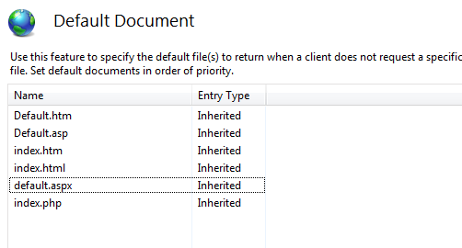

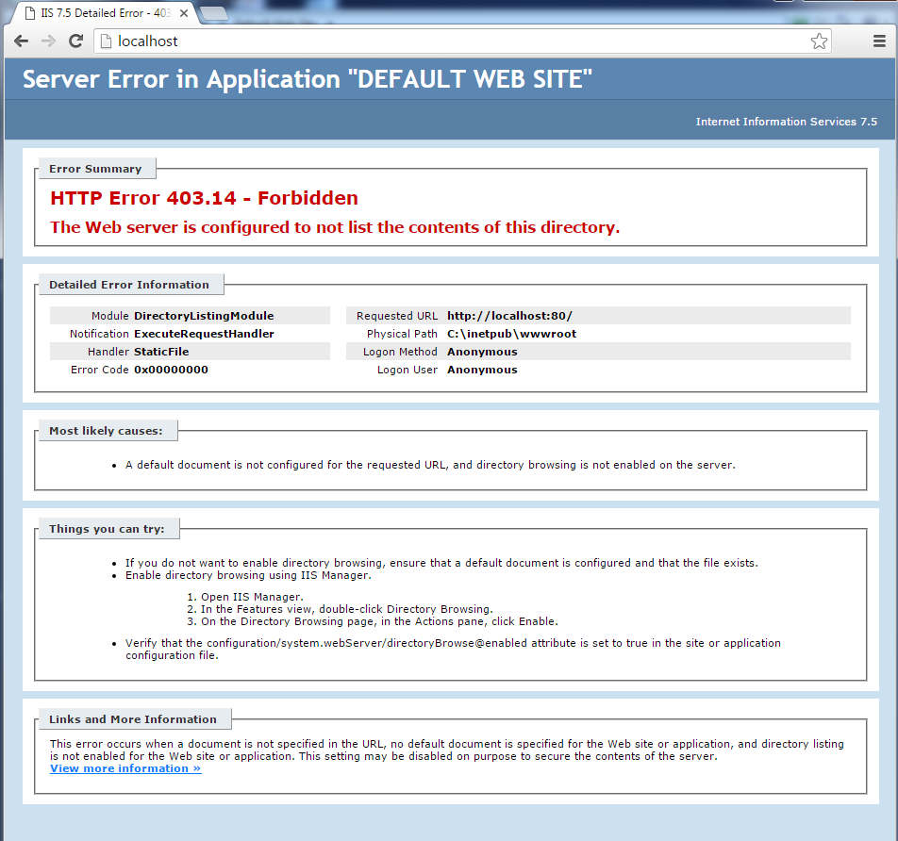  
**The error means that it is a client request error. Essentially it means that the website does not have “Directory Browsing” enabled. It also means that the default document is not configured properly.**

1. Double click on the **Directory Browsing** icon. Enable browsing by clicking on the Enable link on the right hand side. Restart a browser and enter localhost for the URL. What does the resulting page show? Where is this page from?  
   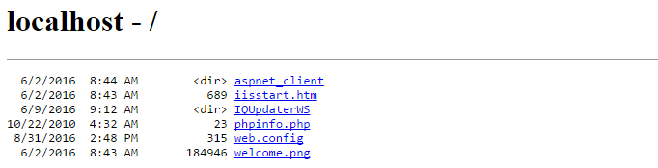  
   **This page is from the directory of aspnet_client inside the Default Web Site.**
2. Return to IIS Manager and Disable Directory Browsing and then go to the Default Document and add the file iisstart.htm to the list of Documents. Access localhost to make sure you got the same results as step 2 above.  
   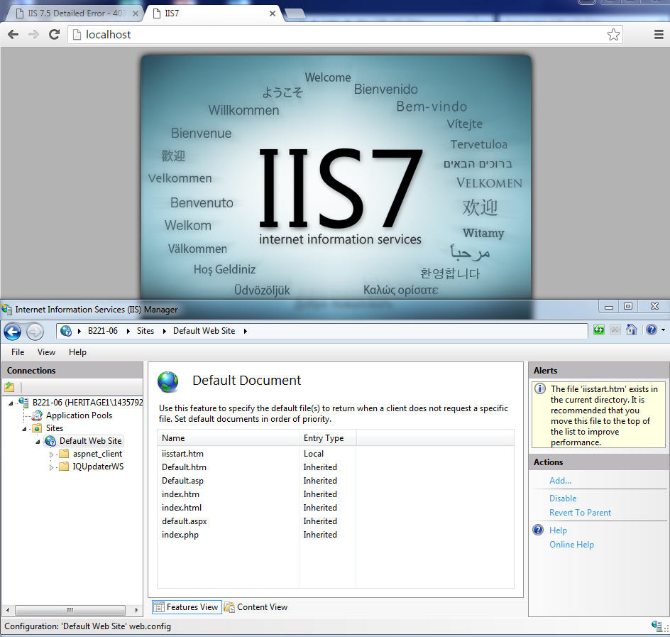
3. Create a new folder at the root of the c: drive called newweb. Copy the files index.html and default.htm from file you downloaded at the start of the lab to this new folder. View both files in the browser to see what they look like and how they are different.
4. Go back to the IIS manager right click and select **Manage Web Site** of the **Default Web Site** and choose the Advanced Settings option. Select the current Physical Path and copy the current value to this document. Change the Physical Path to c:\newweb and select OK. Use the snipping tool to capture the screen showing the changed value for the physical path and paste the result here. Stop and Start the Default Web Site by Right clicking on the Default Web Site icon and selecting Manage Web Site, Restart.

**%SystemDrive%\inetpub\wwwroot**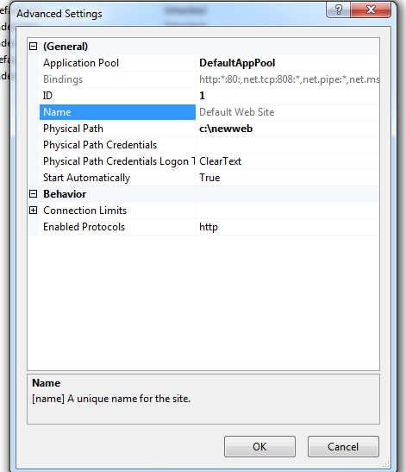

1. Start a browser and enter localhost for the URL. What page is displayed?  
   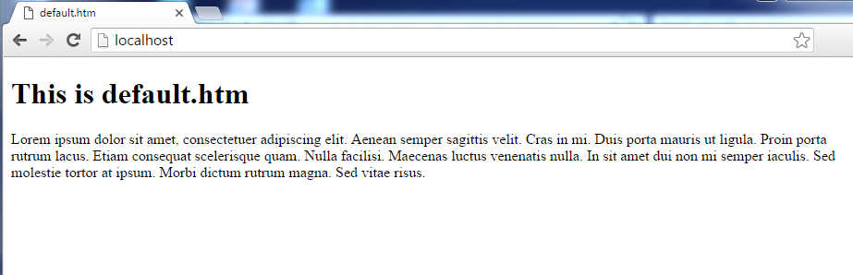

**Default.htm**

1. Go back to the properties of the Default Web and, in the Default Documents tab, move the document name index.html to the top of the list. Use the snipping tool to capture the screen showing the changed value and paste the result here. Start and then stop the web server as above and refresh the page displayed in the browser. What page is displayed this time?  
   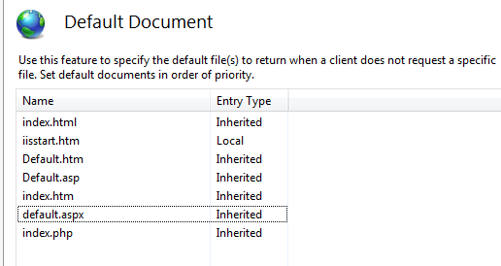  
     
   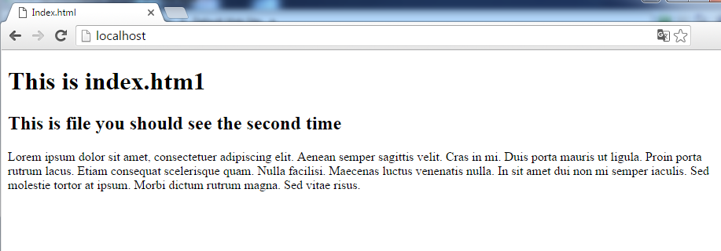  
     
   **index.html is now displayed.**
2. Click on the Default Web Site icon and choose the Bindings action from the right side. On the Site Bindings screen select http and Edit the values. Change the port from 80 to 8080. Use the snipping tool to capture the screen showing the changed value and paste the result here.   
   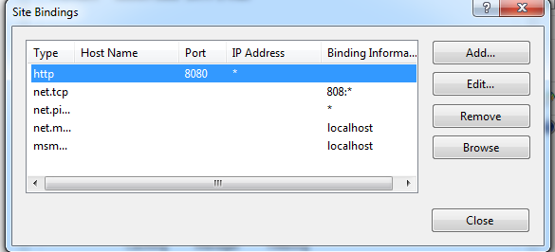  
     
   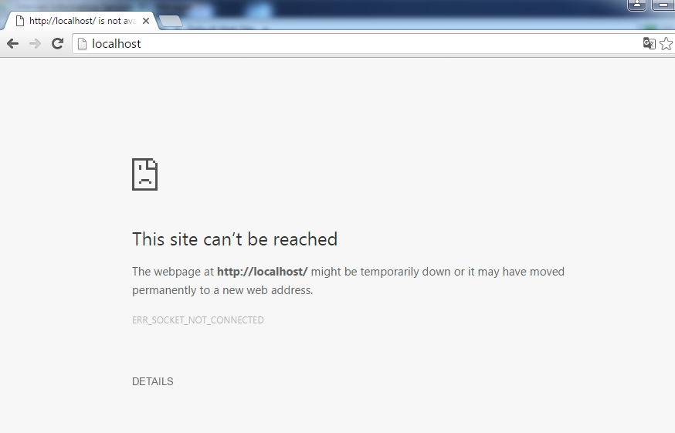
3. Restart the web site and the browser. Enter localhost for the URL (remember you may need to clear cache). What is displayed? Why?  
   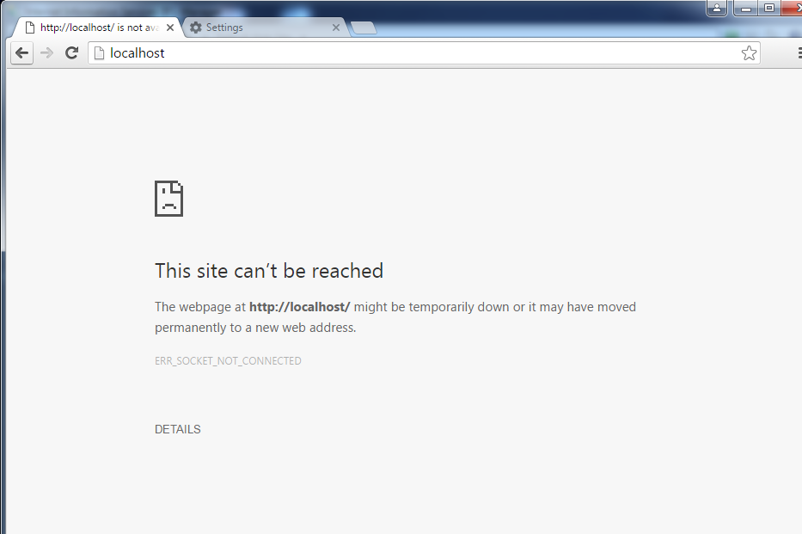  
   **This is displayed because the even though we restarted the server the port is still 8080.**
4. In the browser and enter localhost:8080 for the URL. What is displayed? Why?  
   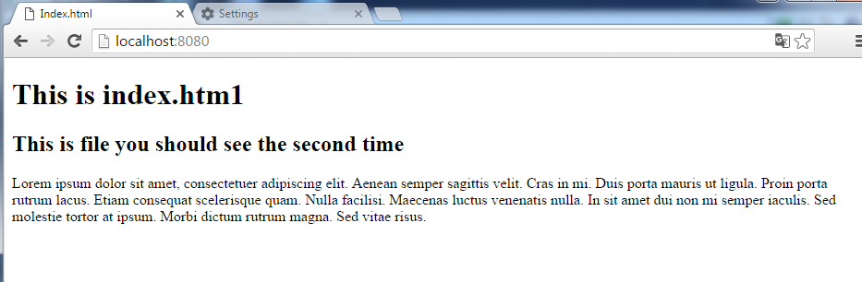  
   **This is because when I just enter in the localhost without specifying a port, the port will automatically be 80. So, by specifying 8080, it means that I will connect to the website using port 8080.**
5. Change the properties of the server back to using TCP Port 80, and the home directory back to what it was originally (%SystemDrive%\inetpub\wwwroot). Re-check localhost to make sure that the IIS start page comes up.

**Error Pages**

1. With the Default Web Site selected double-click on the Error Pages icon. What category of errors are listed?  
   **The categories of errors are client errors for the errors that start with 4xx, and the numbers that start with 5xx are server errors.**
2. Open the folder C:\inetpub\custerr\en-US. What do the errors 401 and 403 mean (double-click to see them in the browser and think about what the messages mean).  
   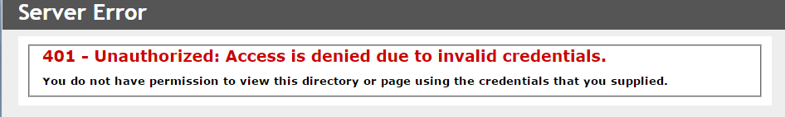  
   **Essentially it means I do not have authorization because I don’t have the proper credentials. As a result I have been denied access.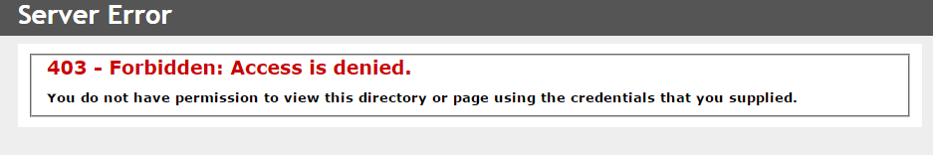 This page also means that I am forbidden from viewing this web page as I do not have permission because I have invalid credentials.**

**Redirection**

1. We are now going to add a virtual directory. Virtual directories are used in the address resolution module to determine where the requested files are located. With the default website selected, right-click and choose Add Virtual Directory… Enter your initials for the alias and end c:\newweb for the Physical Path (the folder you created above). Use the snipping tool to capture the screen and paste the result.  
   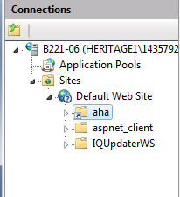
2. Start a browser and enter localhost/yourinitials as the URL. What page is displayed? Explain what the web server did to return this page to you.  
   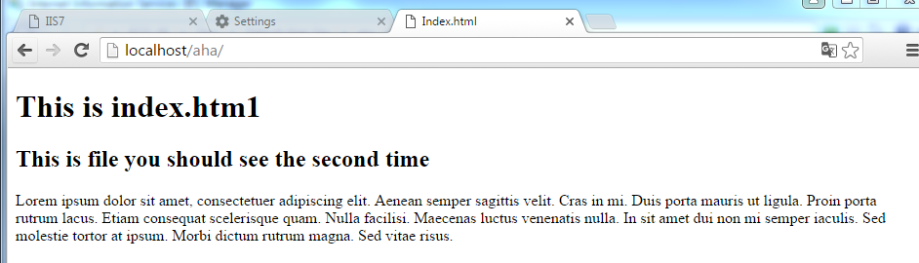

**What the web server did was it took me to the path I created. It looked for the path aha in the localhost.**

**Other Controls**

1. With IIS Manager you can control almost everything about the behaviour of the web server. For example, you can prevent certain types of requests or elements in your request. In IIS Manager select the Request Filtering option. Select the HTTP Verbs tab and “Deny verb…” POST. Capture the screen with the snipping tool and copy here.   
   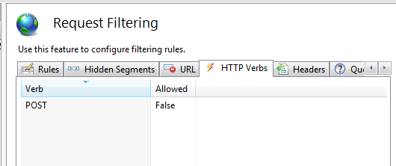
2. Copy the file formPage.html to c:\inetpub\wwwrooot. Start a browser and use the HTTP method to display formPage.html (http://localhost/formPage.html). Enter some values and submit the form. You SHOULD receive an error page. Capture the screen and copy it here.  
   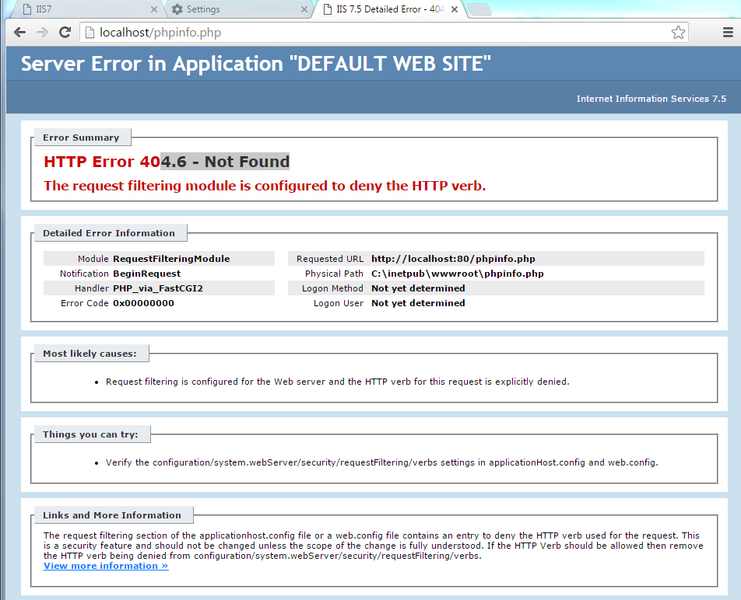
3. Go back and Remove the HTTP verb request filter for POST. Capture the screen and copy here.  
   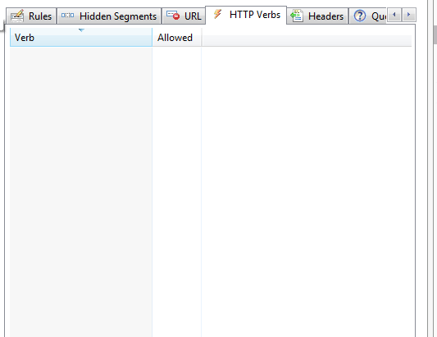
4. IIS can also be set up to always return certain headers. In IIS Manager, select HTTP Response Headers and add the header myHeader with the value of your name. Capture the screen and place it here.

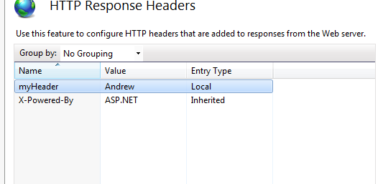

1. In Chrome, Firefox or IE you can look at the network traffic to see the request and response headers and messages. To do this, press F12 to bring up the developer window. Select the Network tab wherever it is displayed. Redisplay formPage.html from the web browser. On the Network page formPage.html should be listed. Select the file and you will see the response command and headers. Check that the header you added is there. Capture the browser screen that shows the header and copy it here.  
   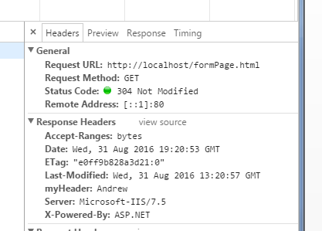
2. Go back to IIS Manager and remove the HTTP Response Header you added.  
   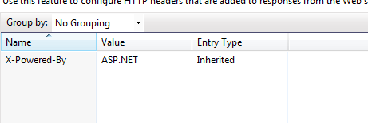
3. We will be using PHP in the second half of the course. Since PHP runs as part of IIS, it can be managed by the IIS Manager. Do this now by double clicking on the PHP Manager icon in the Default Web Site page under the IIS section. What version of PHP is currently running? How many extensions are enabled?   
   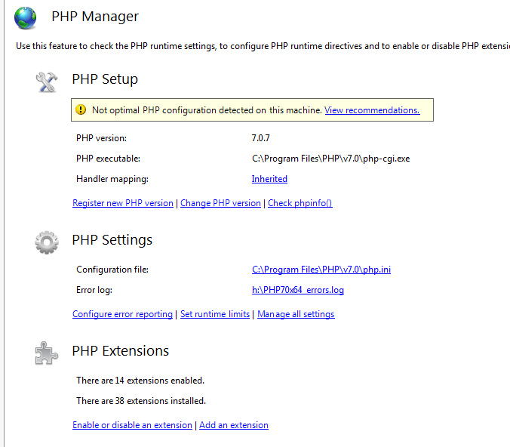  
     
   **The version of PHP is 7.07, there are 14 extensions enabled.**

**Part C – node.js**

1. Look at the file http_node1.js in an editor such as Notepad++ (the file is in the folder you downloaded at the start of the lab). You don’t need to understand the code at this point, but it’s pretty straightforward.
2. Start the node.js command prompt. A command window should be displayed with the H:\> prompt. Change the directory to your 420-C30\Labs\C30_L02\C30_L02_Files.
3. Start node.js with the file above by entering node http_node1.js. You should see a message saying that the server was started on port 3002.
4. Go to CHROME (it can be done in Firefox too I believe) and enter localhost:3002 as the URL. What did you get? Snip it and place it here.

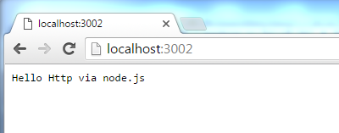

1. What is node.js doing at this point? What is happening when you enter the URL?  
   **Its taking my node.js file and starting a server on port: 3002.**
2. In Chrome, Firefox or IE you can look at the network traffic to see the request and response headers and messages. To do this, press F12 to bring up the developer window. Select the Network tab wherever it is displayed. Refresh the page (Ctrl-F5). On the Network page localhost should be listed. Select localhost and you will see the response command. Select the Headers tab and toggle the view source for the request and response headers. Notice the status code. Notice that it is not exactly what it was set to be in your header. What has been added to the header sent back?  
   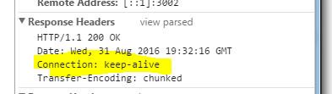

**The connection: keep-alive has been sent back.**

1. In the code, change the res.writeHead line to return 404 instead of 200. Stop node.js using Ctrl-C and restart it the same way again. Refresh the chrome browser again. What does the browser display? What is put in the header? Is this “correct” functionality?  
     
   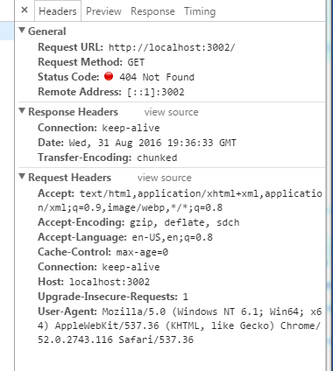  
   **This is correct functionality because we are telling the server to do this.**
2. Stop node.js and restart it using node http_node2.js. Go to Chrome (with developer window open to Network) and enter localhost:3003/a/b/charlie. What is displayed? Now enter localhost:3004/x/y/zulu. What is displayed? Snip BOTH results and save them here.  
   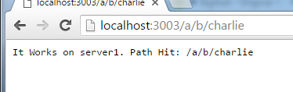  
   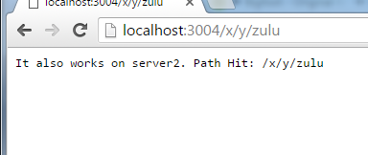
3. What is node doing now? You may want to look at the code to help you. Why would you want node to be listening on two ports?  
   **Node is opening 2 ports, this is because you need one port for responses and one port for requests.**
4. In the developer window on Chrome, next to the Request Headers is a link to view source. Click the link and look at the source of the request header. What headers are the only required ones? What are the extra ones for (they are pretty straightforward).?   
   **The headers required are GET and HOST. The rest are Connection, Upgrade-Insecure-Requests, User-Agent, Accept-Encoding, Accept-Language.**
5. Stop node.js and restart it using node http_node3.js. Go to Chrome (with developer window open to Network) and enter localhost:3005. What is displayed?   
   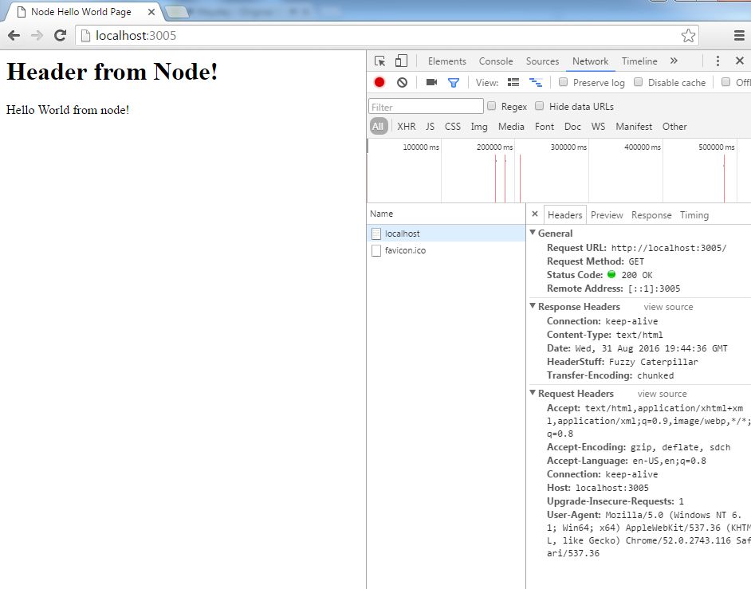
6. Look at the source of the Response Header. What headers have been added? What does this tell you about what an HTTP server can be made to do with headers?

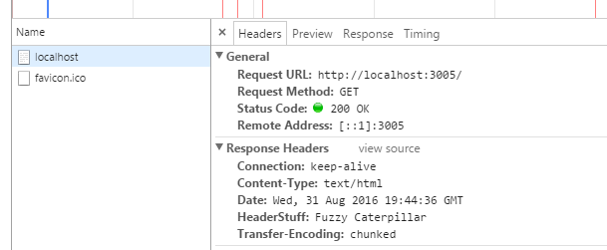  
**A header called HeaderStuff with the value Fuzzy Caterpillar it means that servers can pass information in the form if they wanted.**

**Part D – HTTP commands**

1. What are the http requests/returns, in order, that will be sent/received given the following page resides on an IIS server/

At URL: www.mysite.ca

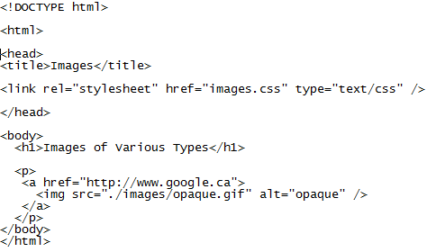

File: images.html in root folder

**Request  
 GET / HTTP/1.1  
 Host: localhost/root/  
 Connection: keep-alive  
 (Blank Line)  
  
 Reponse  
 HTTP/1.1 200 OK  
 Connection: keep-alive  
 Content-Type: text/html  
 (Blank Line)  
  
 Request  
 GET ./images/opaque.gif HTTP/1.1  
 Host: localhost/root/  
 Connection: keep-alive  
 (Blank Line)  
   
 Response  
 HTTP/1.1 200 OK  
 Content Type: image  
 (Blank Line)**

1. A web page called myForm.html contains a form which has the action attribute doIt.php The form has two fields with the names theName and pinCode. The user enters the theName Allan and the pinCode 5555.
   1. What would the HTTP request look like if the form used a get method?  
      **GET ./doIt.php?theName=Allan&pinCode=5555 HTTP/1.1  
      Host: www.myform.html**
   2. What would the HTTP request look like if the form used a post method?  
      **POST ./doIt.php HTTP/1.1  
      Host:** [**www.myform.html**](http://www.myform.html) **(Blank Line)  
      theName=Allan;  
      pinCode=5555;  
      (Blank Line)**

**To submit**

When you have completed the lab exercise, save this file as a PDF document and load the file to Moodle. You MAY have to zip the file if it is too big. This is a lab that cannot really be demonstrated to me, so just hand it in when you complete it.